**Task 4: Inner Join,Full Outer Join, Cross Join, Left Outer Join,Right Outer Join**

**23. Retrieve Payments with Courier Information**

SELECT p.paymentID ,p.amount , p.paymentdate , c.courierid , c.sendername, c.SenderAddress, c.ReceiverName, c.ReceiverAddress, c.Weight, c.TrackingNumber, c.DeliveryDate FROM payment AS p JOIN courier AS c ON p.courierid = c.courierid;

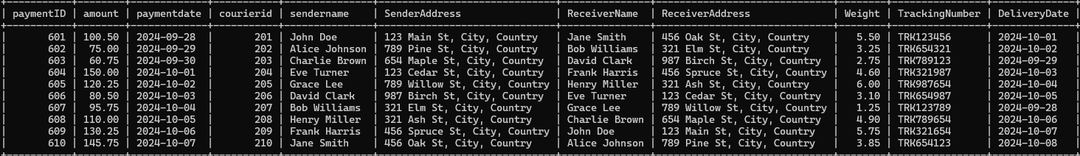

**24. Retrieve Payments with Location Information**

SELECT P.PaymentId,P.Amount,P.PaymentDate,L.LocationName,L.Address FROM payment AS P JOIN Location AS l ON P.LocationId = L.LocationId;

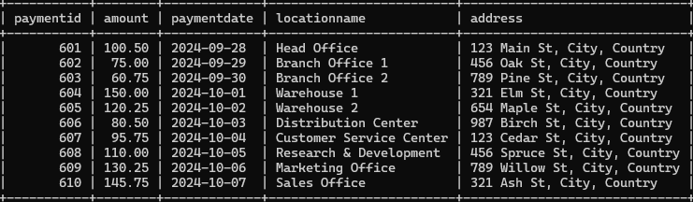

**25. Retrieve Payments with Courier and Location Information**

SELECT P.PaymentID, P.Amount, P.PaymentDate, C.CourierID, C.SenderName, C.ReceiverName, C.TrackingNumber, C.Status, L.LocationID, L.LocationName, L.Address FROM Payment P JOIN Courier C ON P.CourierID = C.CourierID JOIN Location L ON P.LocationID = L.LocationID;

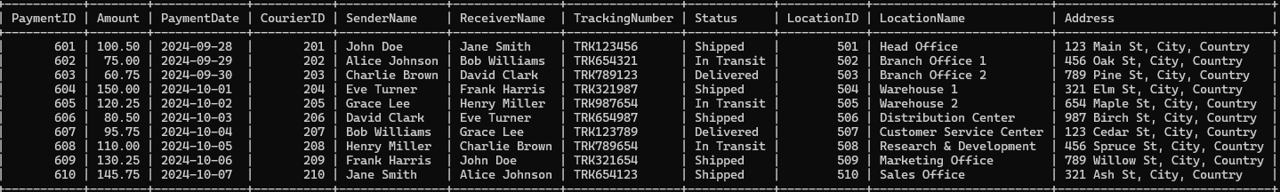

**26. List all payments with courier details**

SELECT P.PaymentId,P.Amount,P.PaymentDate,C.courierid, C.sendername, C.SenderAddress, C.ReceiverName, C.ReceiverAddress, C.Weight, C.TrackingNumber, C.DeliveryDate FROM Payment AS P LEFT JOIN Courier AS C ON P.courierid = C.courierid;

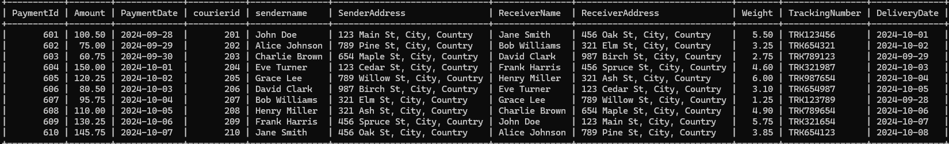

**27. Total payments received for each courier**

SELECT C.CourierID, C.SenderName, C.ReceiverName, SUM(P.Amount) AS TotalPayments FROM Courier C JOIN Payment P ON C.CourierID = P.CourierID GROUP BY C.CourierID, C.SenderName, C.ReceiverName;

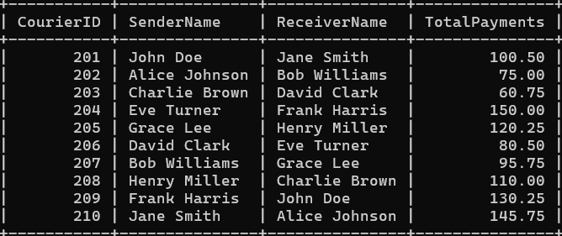

**28. List payments made on a specific date**

SELECT PaymentID, CourierID, LocationID, Amount, PaymentDate FROM Payment WHERE PaymentDate = '2024-10-02';

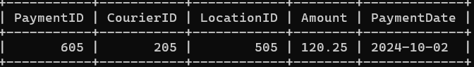

**29. Get Courier Information for Each Payment**

SELECT P.PaymentID, P.Amount, P.PaymentDate, C.CourierID, C.SenderName, C.ReceiverName, C.Weight, C.Status, C.TrackingNumber FROM Payment P LEFT JOIN Courier C ON P.CourierID = C.CourierID;

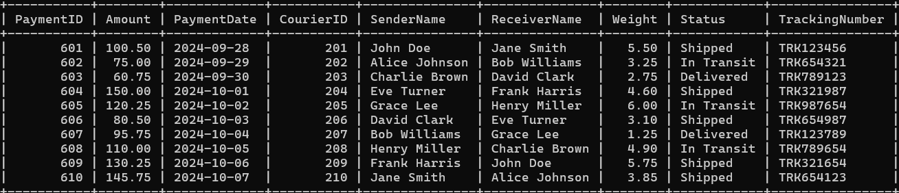

**30. Get Payment Details with Location**

SELECT P.PaymentID, P.Amount, P.PaymentDate, L.LocationName FROM Payment P JOIN Location L ON P.LocationID = L.LocationID;

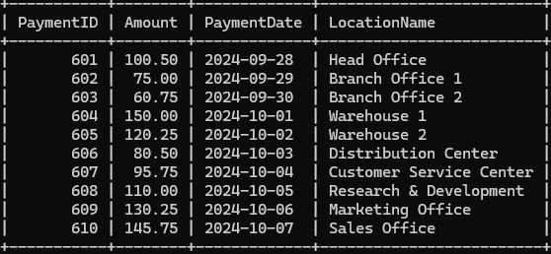

**31. Calculating Total Payments for Each Courier**

SELECT C.CourierID, C.SenderName, C.ReceiverName, SUM(P.Amount) AS TotalPayments FROM Courier C JOIN Payment P ON C.CourierID = P.CourierID GROUP BY C.CourierID, C.SenderName, C.ReceiverName;



**32. List Payments Within a Date Range**

SELECT PaymentID, CourierID, LocationID, Amount, PaymentDate FROM Payment WHERE PaymentDate BETWEEN '2024-09-30' AND '2024-10-04';

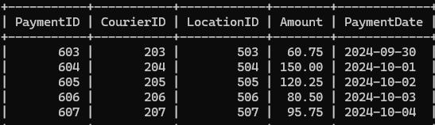

**33. Retrieve a list of all users and their corresponding courier records, including cases where there are no matches on either side**

SELECT U.Name, C. CourierID, C.SenderName , C.ReceiverName ,C. ReceiverAddress FROM courier c OUTER JOIN User U ON C.UserId = U.UserId;

**34. Retrieve a list of all couriers and their corresponding services, including cases where there are no matches on either side**

SELECT c.courierid, cs.serviceid, cs.servicename, cs.cost FROM courier c OUTER JOIN courierservice cs ON c.serviceid = cs.serviceid;

**35. Retrieve a list of all employees and their corresponding payments, including cases where there are no matches on either side**

**36. List all users and all courier services, showing all possible combinations.**

SELECT U.UserID, U.Name, U.Email, CS.ServiceID, CS.ServiceName, CS.Cost FROM User U CROSS JOIN CourierServices CS;

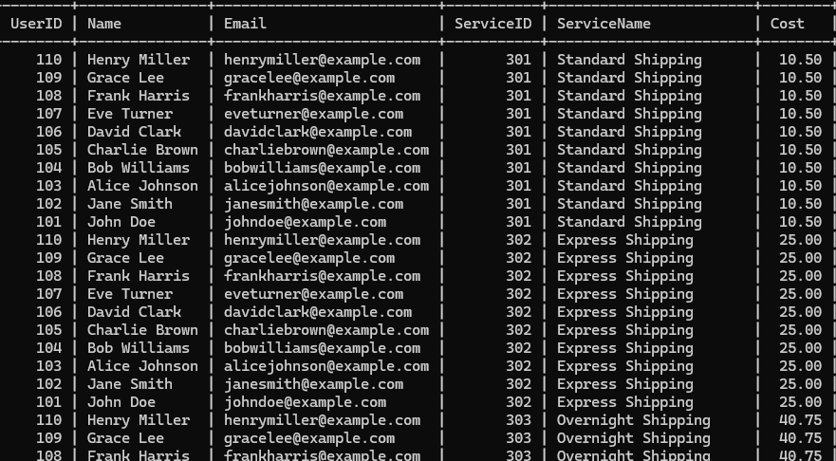

**37. List all employees and all locations, showing all possible combinations:**

SELECT E.EmployeeID, E.Name, L.LocationID, L.LocationName FROM Employee E CROSS JOIN Location L;

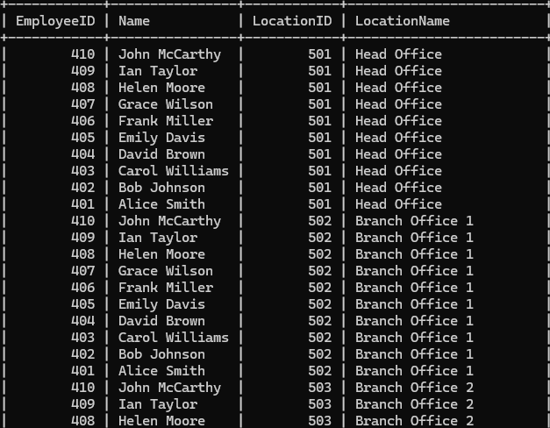

**38. Retrieve a list of couriers and their corresponding sender information (if available)**

SELECT CourierID, SenderName, SenderAddress FROM Courier;

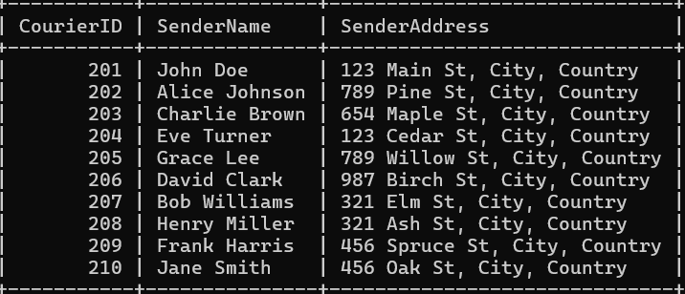

**39. Retrieve a list of couriers and their corresponding receiver information (if available):**

**SELECT CourierID, ReceiverName, ReceiverAddress FROM Courier;**

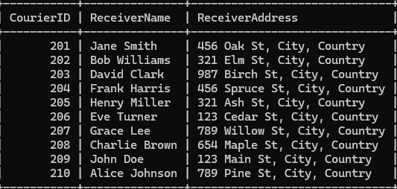

**40. Retrieve a list of couriers along with the courier service details (if available):**

SELECT C.CourierID, C.SenderName, C.ReceiverName, C.Weight, C.Status, C.TrackingNumber, C.DeliveryDate, CS.ServiceID, CS.ServiceName, CS.Cost FROM Courier C LEFT JOIN CourierServices CS ON C.ServiceID = CS.ServiceID ORDER BY C.CourierID;

**41. Retrieve a list of employees and the number of couriers assigned to each employee:**

SELECT Name , COUNT(CourierId) FROM Employee GROUP BY Name;

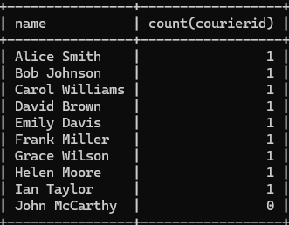

**42. Retrieve a list of locations and the total payment amount received at each location:**

SELECT L.LocationID, L.LocationName, SUM(P.Amount) AS TotalAmount FROM Location L LEFT JOIN Payment P ON L.LocationID = P.LocationID GROUP BY L.LocationID, L.LocationName;

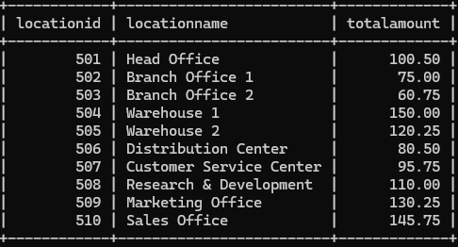

**43. Retrieve all couriers sent by the same sender (based on SenderName).**

SELECT CourierID, SenderName, ReceiverName, Weight, Status, TrackingNumber, DeliveryDate FROM Courier WHERE SenderName = 'Grace Lee';



**44. List all employees who share the same role.**

**45. Retrieve all payments made for couriers sent from the same location.**

SELECT P.PaymentID, C.CourierID, C.SenderName, C.ReceiverName, P.Amount, P.PaymentDate, L.LocationName FROM Payment P JOIN Courier C ON P.CourierID = C.CourierID JOIN Location L ON P.LocationID = L.LocationID WHERE P.LocationID IN ( SELECT LocationID FROM Payment GROUP BY LocationID HAVING COUNT(*) > 1) ORDER BY L.LocationName, P.PaymentDate;

**46. Retrieve all couriers sent from the same location (based on SenderAddress).**

SELECT CourierID, SenderName, SenderAddress, ReceiverName, Weight, Status, TrackingNumber, DeliveryDate FROM Courier WHERE SenderAddress IN ( SELECT SenderAddress FROM Courier GROUP BY SenderAddress HAVING COUNT(*) > 1) ORDER BY SenderAddress, DeliveryDate;

**47. List employees and the number of couriers they have delivered:**

select e.name , count(e.courierid) from employee e group by name**;**

48. Find couriers that were paid an amount greater than the cost of their respective courier services

SELECT C.CourierID, P.Amount AS PaymentAmount, CS.Cost AS ServiceCost FROM Courier C JOIN Payment P ON C.CourierID = P.CourierID JOIN CourierServices CS ON C.ServiceID = CS.ServiceID WHERE P.Amount > CS.Cost;

**Scope:**

**49. Find couriers that have a weight greater than the average weight of all couriers**

SELECT * FROM Courier WHERE Weight > (SELECT AVG(Weight) FROM Courier);

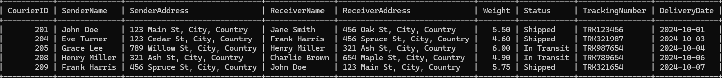

**50. Find the names of all employees who have a salary greater than the average salary:**

SELECT Name FROM Employee WHERE Salary > (SELECT AVG(Salary) FROM Employee);



**51. Find the total cost of all courier services where the cost is less than the maximum cost**

SELECT SUM(Cost) AS TotalCost FROM CourierServices WHERE Cost < (SELECT MAX(Cost) FROM CourierServices);

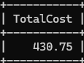

52. Find all couriers that have been paid for

SELECT C.* FROM Courier C JOIN Payment P ON C.CourierID = P.CourierID;

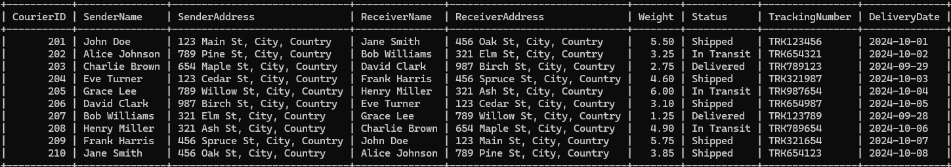

**54. Find all couriers whose weight is greater than the weight of all couriers sent by a specific sender (e.g., 'SenderName'):**

SELECT * FROM Courier WHERE Weight > (SELECT MAX(Weight) FROM Courier WHERE SenderName = 'Eve Turner');

